*SIMPLE LINEAR REGRESSION;

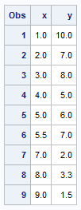

**data** demo;

input x y;

cards;

1 10

2 7

3 8

4 5

5 6

5.5 7

7 2

8 3.3

9 1.5

;

**proc** **print**;

**run**;

**proc** **reg** data=demo;

model y=x;

**run**;

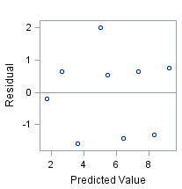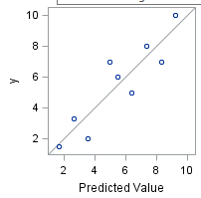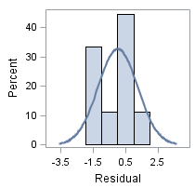

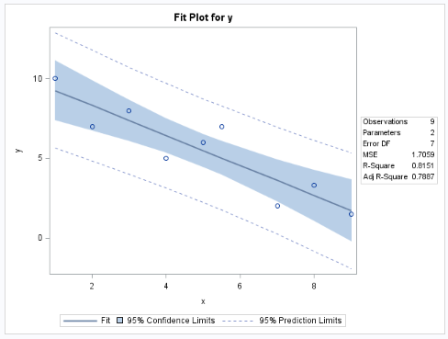

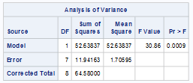



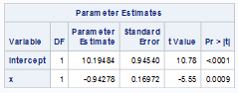

**proc** **corr**;

var y x;

with y;

**run**;

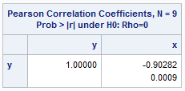

**proc** **sgscatter** data=demo;

plot y*x;

**run**;

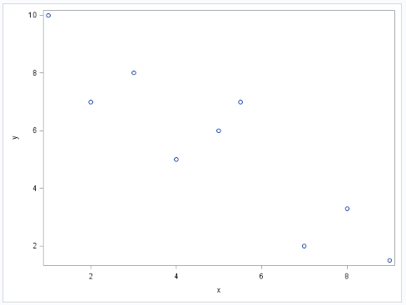

*ATAU;

**proc** **sgscatter**;

matrix y x;

**run**;

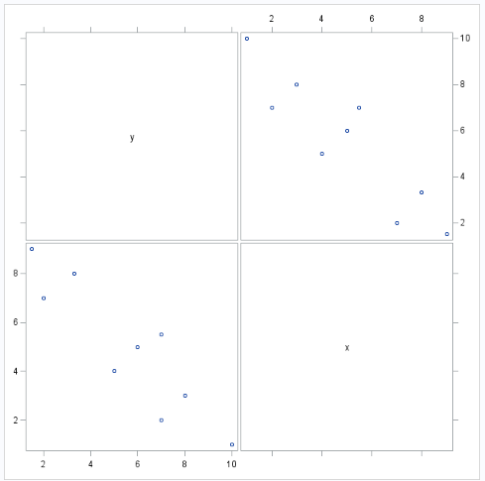

*y-hat = B0 + B1*X ;

* H0 :B1 =0 ;

* H1 :B1 !=0 ;

**proc** **reg** data=demo;

model y=x / clb;

**run**;

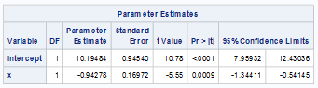

**proc** **reg** data=demo alpha=**0.1**;

model y=x / clb;

**run**;

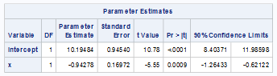

*MULTIPLE LINEAR REGRESSION;

libname BP "C:\Users\Admin\Desktop\SAS\PROJECT SAS 1.0";

**data** BP;

infile "C:\Users\Admin\Desktop\SAS\PROJECT SAS 1.0\BP.xls" dlm=',';

input cases BP age weight pulse stress;

**run**;

**proc** **print** data = BP;

**run**;

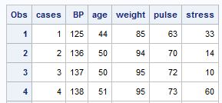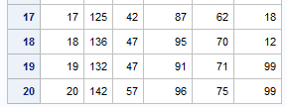

**proc** **freq** data = BP;

table BP;

**run**;

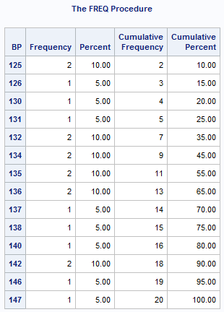

**proc** **sgscatter** data = BP;

matrix BP cases age weight pulse stress;

**run**;

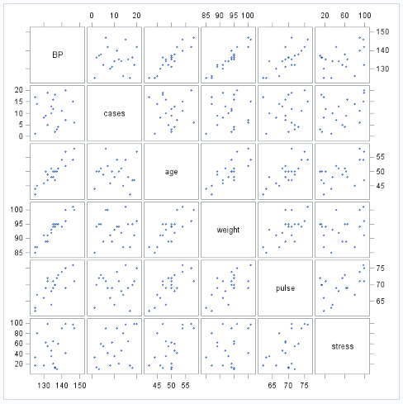

**proc** **reg** data = BP;

model BP = cases age weight pulse stress;

plot BP*(stress)/pred;

**run**;

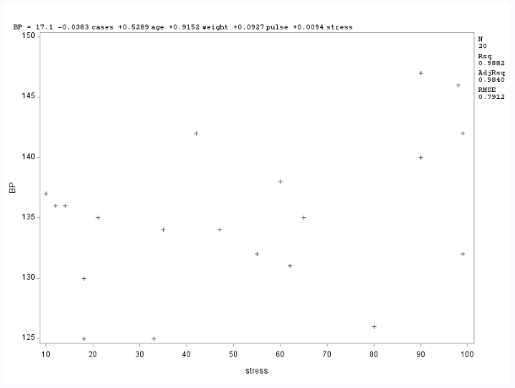

**proc** **reg** plot=all;

model BP = cases age weight pulse stress;

**run**;

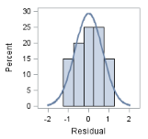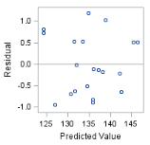

title1 "Residual vs. Predicted Plot";

**proc** **reg**;

model BP = cases age weight pulse stress;

plot r.*p.;

**run**;

title;

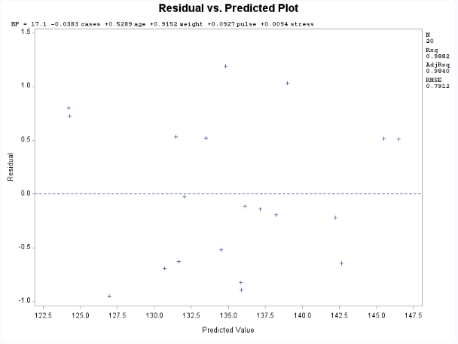

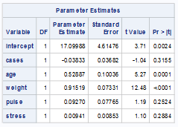

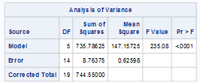

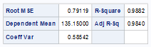

*TEST ONE VARIABLE;

**proc** **reg** data=BP;

model BP = cases age weight pulse stress;

test cases=**0**,age=**0**,weight=**0**,pulse=**0**;

**run**;

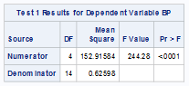

*MULTICOLLINEARITY;

**proc** **reg** data=BP;

model BP = cases age weight pulse stress / tol vif collin;

**run**;

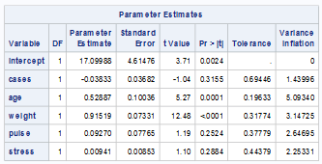

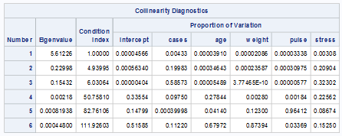

EXAMPLE 2:

**data** demo;

input y x1 x2 x3;

cards;

7 1 13 3

8 2 18 6

9 3 2 1

15 4 21 8

18 5 5 0

20 6 8 6

21 7 5 6

;

**proc** **print**;

**run**;

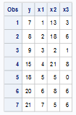

**proc** **sgscatter**;

matrix y x1 x2 x3;

**run**;

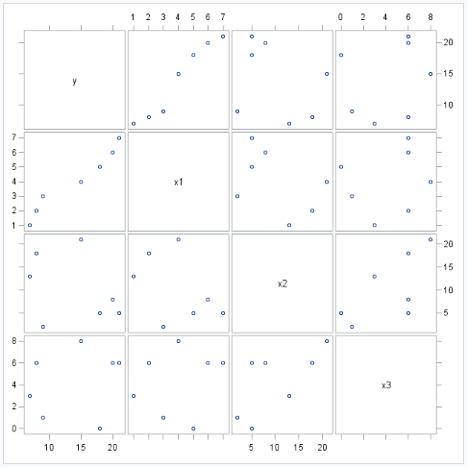

**proc** **reg** data = demo;

model y = x1 x2 x3;

**run**;

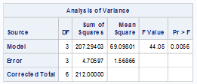



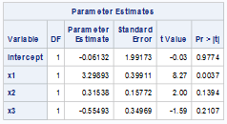

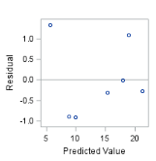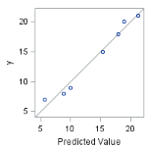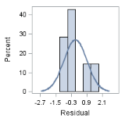

*MODEL y-hat = B0 + B1*X1 + B2*X2 + B3*X3 ;

*OVERALL F-TEST;

* HO = B1=B2=B3=0,

H1 = at least one of B1, B2, B3 is not 0;

* partial F-test;

*H0: B2=B3=0

H1: At least one of B2, B3 is not 0;

**proc** **reg** data = demo;

model y = x1 x2 x3;

test x2=**0**, x3=**0**;

**run**;

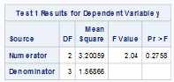

**proc** **reg** data = demo;

model y = x1 x2 x3 / clb;

**run**;

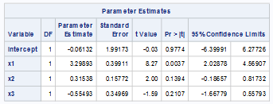

**proc** **reg** data = demo alpha=**0.1**;

model y = x1 x2 x3 / clb;

**run**;

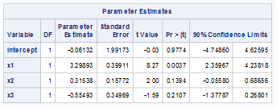

**proc** **reg** data = demo alpha=**0.1**;

model y = x1 x2 x3 / cli clm;

**run**;

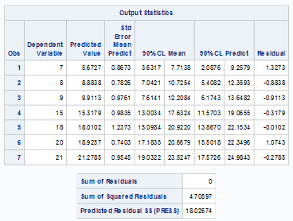

**data** demo2;

y=**.**;x1 =**4**; x2=**3**; x3=**4**;

**proc** **print**;

**run**;



**data** demo;

set demo demo2;

**proc** **print**;

**run**;

